# Supplementary materials for:

# A Survey on the Attitudes Towards and Perception of Reproducibility and Replicability in Sports and Exercise Science

Jennifer Murphy,1 Cristian Mesquida,1 & Joe P. Warne1

1 School of Biological, Health, and Sports Sciences, Technological University Dublin, Tallaght, Dublin, Ireland.

**Corresponding Author**: Jennifer Murphy, School of Biological, Health, and Sports Sciences, Technological University Dublin, Tallaght, Dublin, Ireland. Email: [x00170612@mytudublin.ie](mailto:x00170612@mytudublin.ie)

**ORCIDs:**

Jennifer Murphy - [0000-0001-8624-3828](https://orcid.org/0000-0001-8624-3828)

Cristian Mesquida - ﻿0000-0002-1542-8355

Joe P. Warne - 0000-0002-4359-8132

Preprint for the above titled manuscript available at <https://doi.org/10.51224/SRXIV.234>

## **Additional Survey Results**

In response to a survey question on the extent to which the reproducibility or replicability crisis is flagged, 47% (n = 240) of respondents feel it is not flagged enough, while 3% (n = 13) felt it was flagged too much. 22% (n = 111) felt it was flagged a reasonable amount and 28% (n = 144) were unsure.

Respondents believe better mentoring and supervision, more robust experimental design and better understanding of statistics were the highest factors that could improve the reproducibility and replicability of sports and exercise science research (Figure 1).

Figure 1. Descriptive results of the response to the survey statement “Please use the scale below to indicate how likely you think the following factors would be to improve the reproducibility and replicability of research”.

The number to the left of the bar indicates the percentage of participants who responded with “very likely”, “fairly likely” or “somewhat likely” while the number on the right indicates the percentage of participants who responded with “somewhat unlikely”, “fairly unlikely” or “very unlikely”. The number in the centre of the bar indicates the percentage of those who responded “neither likely nor unlikely”. Statements are ordered according to the percentage of agreement.

Most respondents feel that published results in sports and exercise science are “somewhat likely” to be reproducible or replicable (Figure 2). This appears to slightly contradict the opinions of the same respondents as over three-quarters of these respondents believe there a replication and reproducibility crisis in sports and exercise science, with over 42% identifying this crisis as “significant” (see Figure 1 in main manuscript).

Figure 2. Descriptive results of the response to the survey question “In your opinion, how likely are published results in the field of sports and exercise science reproducible or replicable?”

When sports and exercise science researchers were asked about their opinions on the reproducibility and replicability of our field compared to other fields, many felt it was the same (Figure 3).

Figure 3. Descriptive results of the response to the survey statement “Please complete the following sentence: In my opinion, the level of reproducibility or replicability in my field is.....compared to other fields?”

Following on from the question presented in Figure 3, respondents were asked about their level of agreement with the statements that (1) reproducibility and replicability is a major problem in our field, and (2) reproducibility and replicability is a major problem in all fields. Respondents overwhelming agreed it is a major problem for all fields.

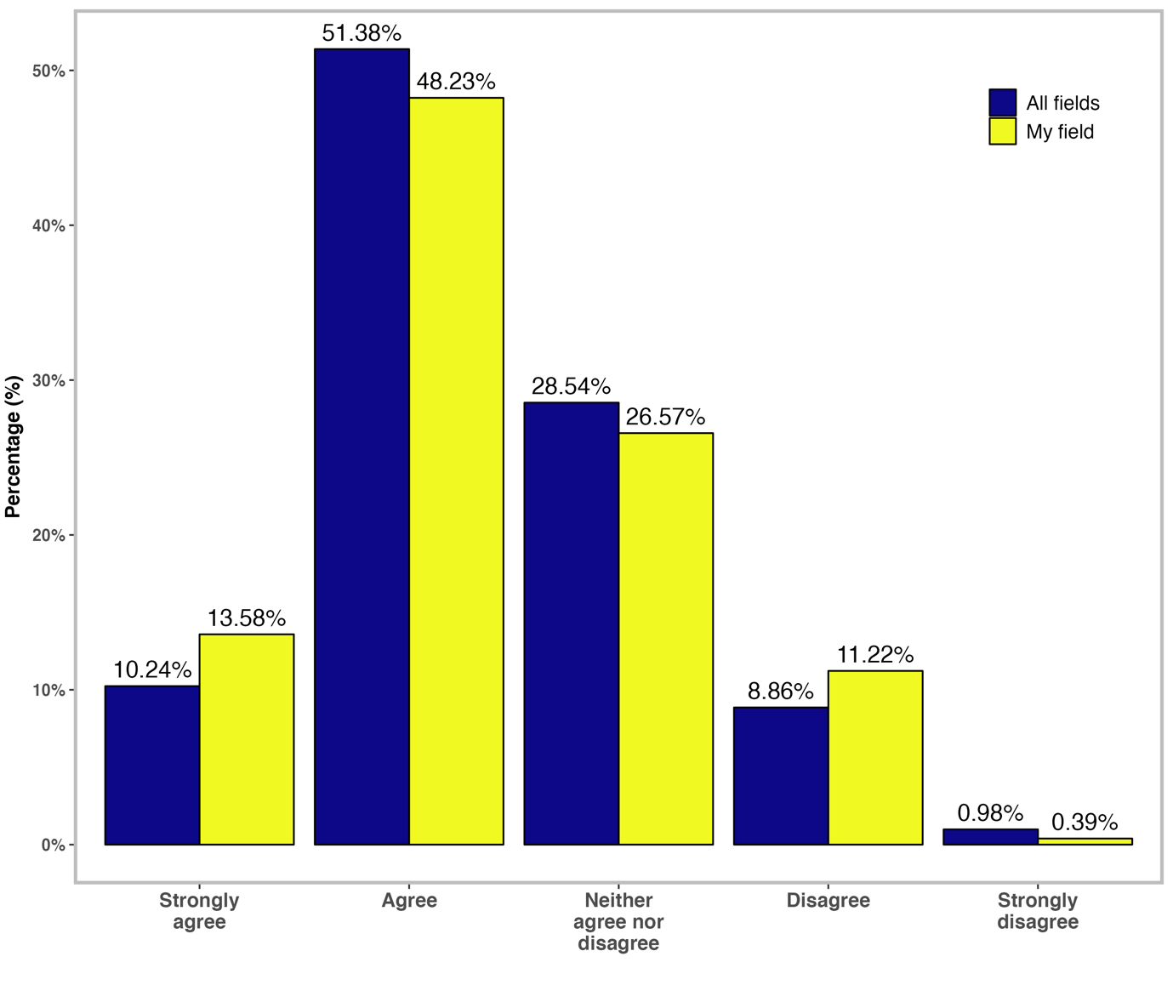

Figure 4. Descriptive results of the response to the survey statements “I think that the failure to reproduce or replicate scientific studies is a major problem in my field” and “I think that the failure to reproduce or replicate scientific studies is a major problem in other fields”.

Survey respondents were asked about their interpretation of a failure to reproduce or replicable findings in original studies. Many respondents disagreed with the statement that a failure means the original study finding is wrong, but this was followed closely by “neither agree nor disagree” (Figure 5). This may possibly indicate lack of clarity in the understanding of failed replications.

Figure 5. Descriptive results of the response to the survey statements “I think that a failure to reproduce or replicate a result most often means that the original finding is wrong” and “I think that a failure to reproduce or replicate rarely detracts from the validity of the original finding”

In the survey, not only did we aim to understand the perception of reproducibility and replicability amongst sports and exercise science researchers, but we also aimed to discover how often they thought or spoke about, and questioned reproducibility and replicability in the field. According to Table 1, many of the surveyed researchers considered the concepts on a weekly or monthly basis.

Table 1. Descriptive results of the response to the survey question “How often do you do any of the following?”

In response to question on directives from funding agencies and journal publishers, 65% (n = 332) of respondents had not encountered any efforts or directives from funding agencies that were designed to improve reproducibility and replicability while 18% (n = 94) had. Contrastingly, 65% (n = 331) of respondents had encountered efforts or directives from journal publishers that were designed to improve reproducibility and replicability while 31% (n = 158) had not.

Researchers neither agreed nor disagreed that efforts from funding agencies are helpful to promote reproducibility and replicability. However, they agreed that fundings agencies should encourage reproducibility and replicability (Figure 6).

Figure 6. Descriptive results of the response to the survey question “To what extent do you agree or disagree with the following statements?”

Similar to the question above about efforts from funding agencies, we also asked researchers about the efforts from journal publishers to promote reproducibility and replicability. A higher percentage of the respondents agreed efforts from journal publishers are helpful compared to funding agencies (46.18% vs 40.90% respectively). The most contrasting difference in these questions was that respondents believe efforts from journal publishers are having a positive impact on the field compared to funding agencies (44.62% vs 19.77%) (Figure 7).

Figure 7. Descriptive results of the response to the survey question “To what extent do you agree or disagree with the following statements?”

In response to a question about establishing procedures for reproducibility and replicability, 56% (n = 286) of respondents have established procedures to ensure reproducibility or replicability of their work either themselves, or as a laboratory group, meaning 44% (n=222) have not. Of the 286 researchers who have, 7% (n =21) established the procedures within the last year from the survey distribution, 20% (n =57) in the last two years, 31% (n = 88) in the last five years and 19% (n = 55) within the last ten years or longer. 13% (n = 65) stated the procedures had already been in place when they joined the laboratory. 70% (n = 199) felt the quality of their research has improved as a result while 7% (n = 20) did not feel their research quality improved, and 23% (n = 67) did not know. Overall, for those who established procedures to ensure reproducibility or replicability, 83% (n = 238) felt it the procedures had a positive effect on the laboratory, while 1% (n = 3) felt it had a negative effect and 16% (n = 45) stated the changes had not affected the laboratory. 45% (n = 129) still wish to introduce further changes and 14% (n = 40) do not wish to introduce changes while the remaining individuals were unsure (41%, n =117).

Finally, respondents were asked whether they had every tried and failed to reproduce or replicate their own work or another individual’s work, in addition to publishing successful or failed attempts to reproduce or replicate work. Most respondents selected “no” for many of these statements (Table 2).

Table 2. Statements on reproducibility and replicability of experiments

